FUNDAMENTALS OF COMPUTER PROGRAMMING


Submitted By:
Sadiksha Pyakurel
Section: C
Student Id: 11389

Assignment of week-1 & 2

Part-1:
Question no 1:
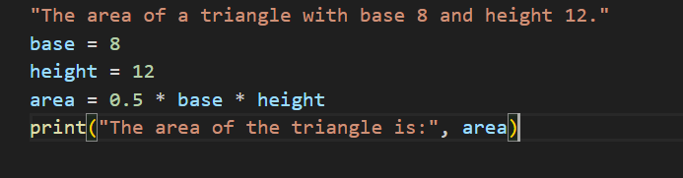
Output:
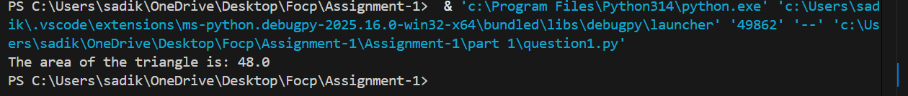

Question no 2:
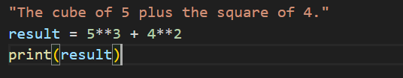
Output:
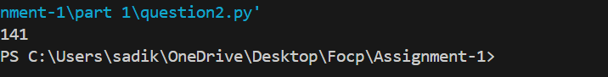

Question no 3:
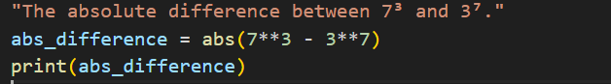
Output:
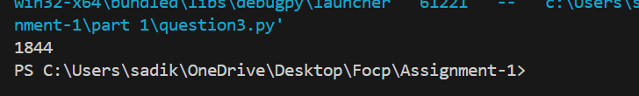

Question no 4:
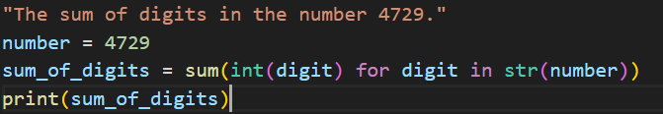
Output:
Question no 5: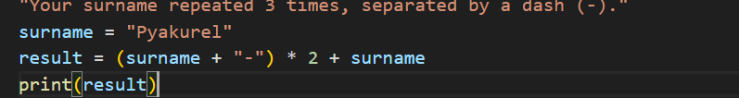Output:
Question no 6:
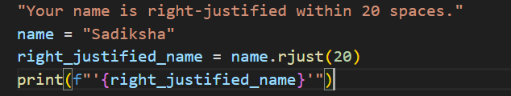
Output:
Question no 7:
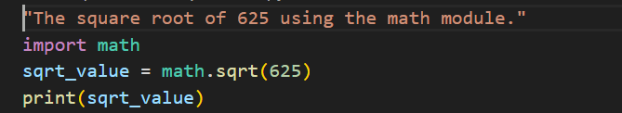
Output:
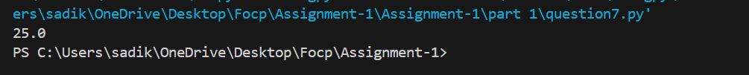
Question no 8: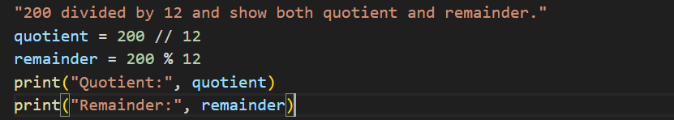Output: 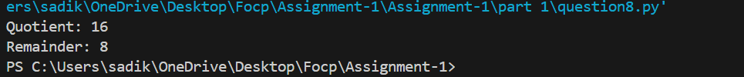

Question no 9:
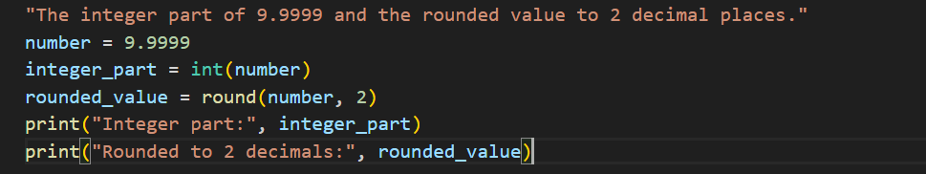
Output:
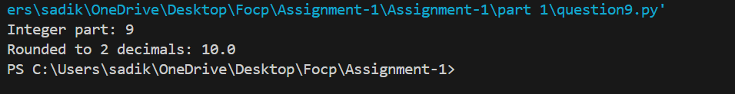

Question no 10:
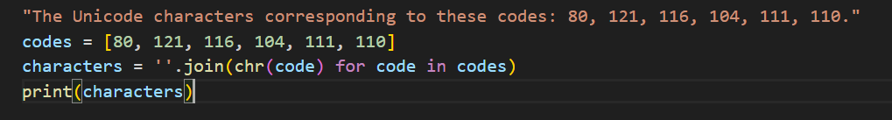
Output: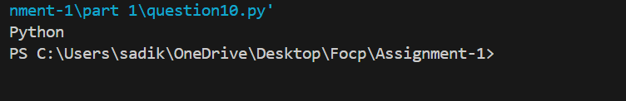

Part-2

Question no 1:
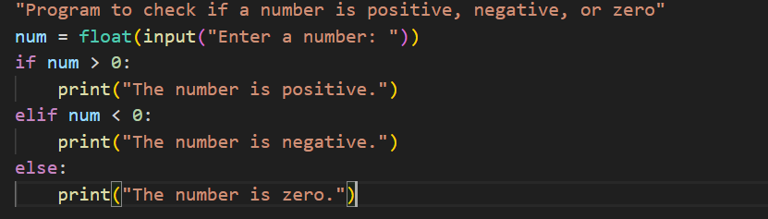
Output:
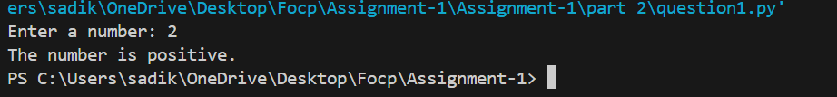

Question no 2:
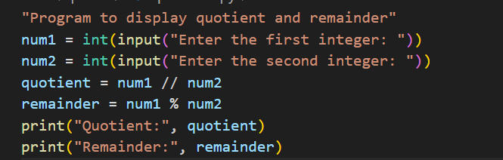
Output: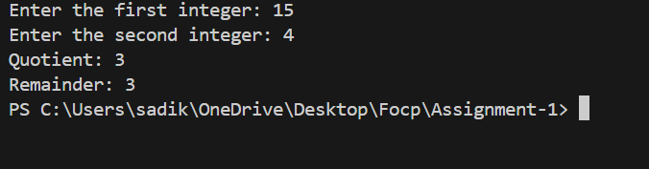

Question no 3:
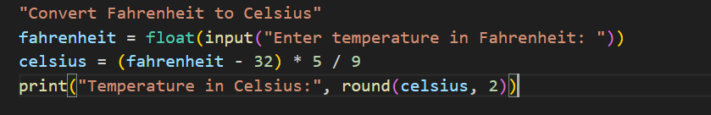
Output:
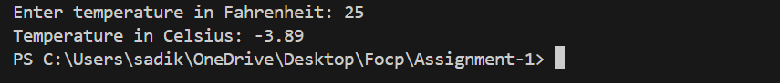
Question no 4:
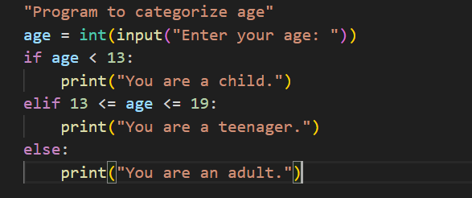
Output:
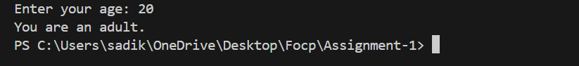
Question no 5:
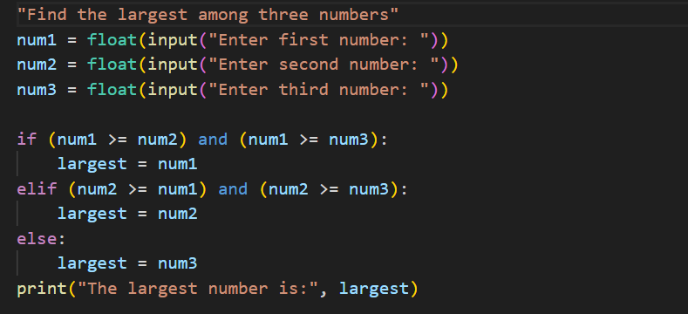
Output:
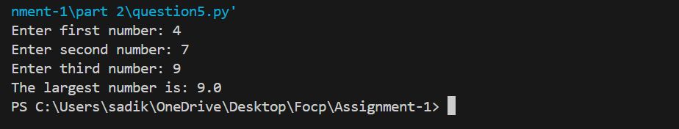
Question no 6:
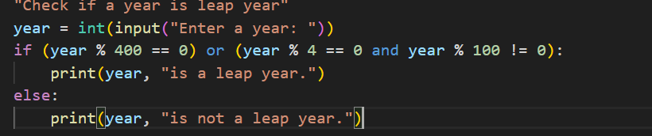
Output:
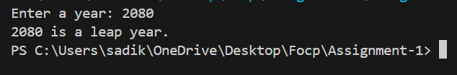
Question no 7:
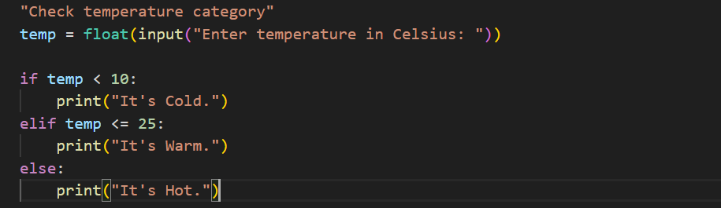
Output:
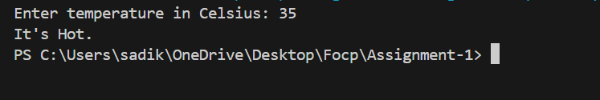
Question no 8:
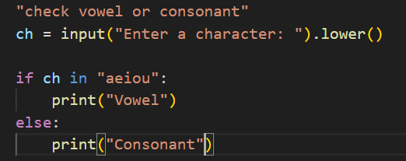
Output:
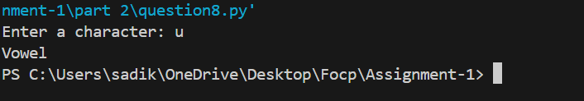

Question no 9:
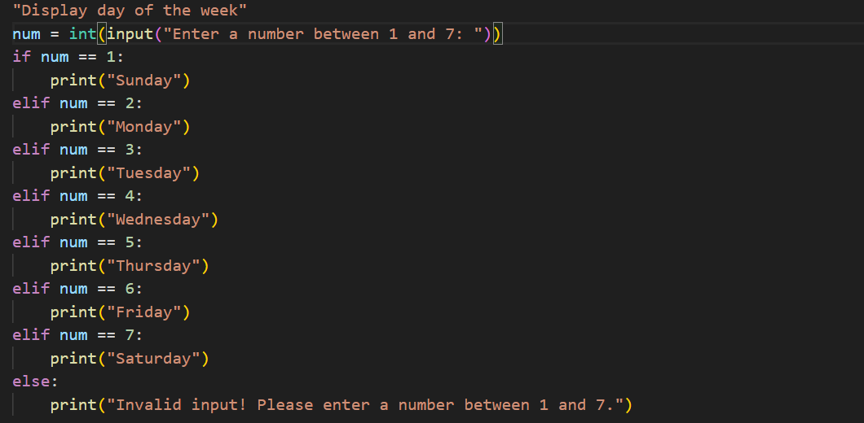
Output:
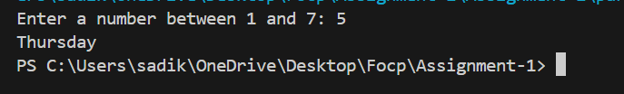

Question no 10:
n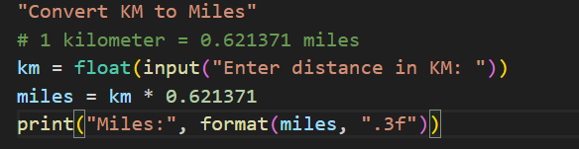
Output:
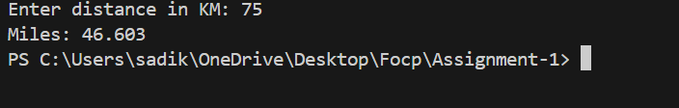
Question no 11:
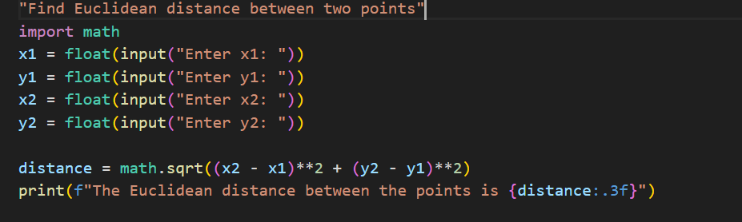
Output:
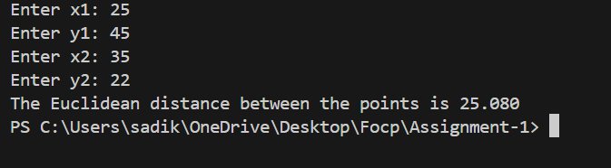
Question no 12:
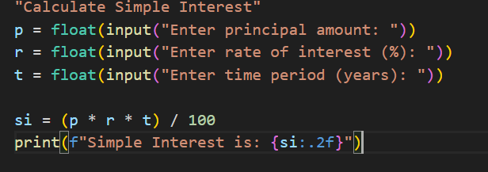
Output:
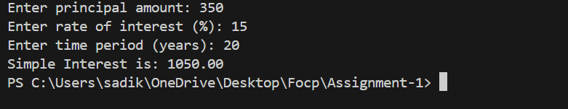
Question no 13:
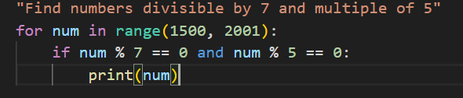

Output:
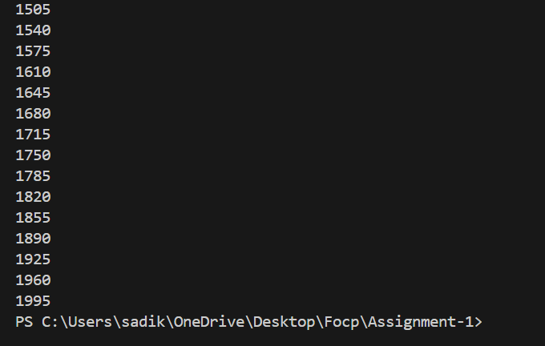
Question no 14:
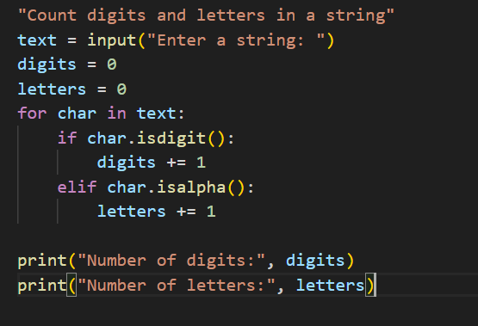
Output:
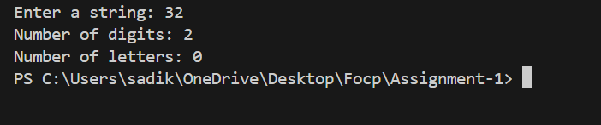

Question no 15:
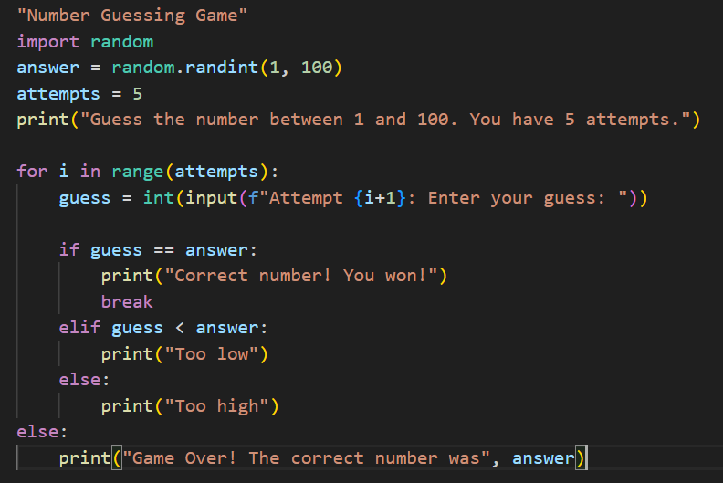
Output:
